Wednesday, 30th September 2020

Dear Parents/Carers
As you are aware, our schools are now fully open and we are rapidly making our way through the term.
To date, as expected, we have had a number of students and staff display COVID-19 symptoms, but as yet we have had no confirmed cases in the school. At some point this will no doubt change.
With this in mind I am writing to outline how the school will manage the circumstances if/ when a positive case is identified.
As required, the school will seek immediate advice from local Public Health advisors and the DfE. They will work with the school to identify any students or staff that have been in close contact with the individual testing positive in the last 48 hours. They will be asked to self-isolate for 14 days and to arrange a test if symptoms are displayed. (Examples of close contact include: close face to face contact (under 1 metre) for any length of time, including talking to them or coughing on them; being within 1 to 2 metres of each other for more than 15 minutes, including travelling in a small vehicle; spending lots of time in your home, such as cleaning it).
On this basis the schools will no longer operate as ‘bubbles’ as previously described. This means that we can be more proportionate and targeted if we need to ask staff or students to self-isolate at home.
Cont/

2
Of course we will continue with all of our ongoing and established mitigations, including:
- Parents and other visitors remaining off site as far as possible. If you are invited to school for any reason, please make yourself known to reception and wait either outside or in your car. A member of school staff will then come out to see you.
- A strong emphasis on following extended hygiene protocols.
- In the event of an individual displaying symptoms of Covid-19 whilst in school, they will be returned home as soon as possible. School will offer any necessary advice so that a Covid test is taken.
- Students are able to wear face masks if they so wish.
On a more positive note, both the students and staff, continue to show a remarkable resilience during these times. This has been, and continues to be one of the biggest challenges for our education system and yet the atmosphere in school remains, for the most part, calm and purposeful.
As previously stated, we all know how quickly things can change in the current climate, and we would like to reassure you all that we will act, as soon as possible, to keep you updated.
As always, if anyone has any concerns, please don’t hesitate to get in touch.
Yours faithfully
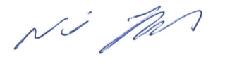
Neil Toplass
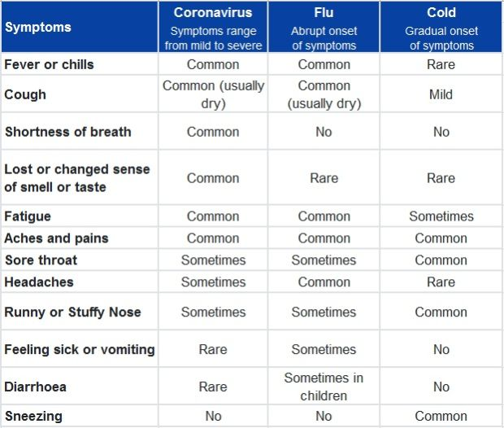
Executive Head Teacher

